27th April 2023

YOKOHAMA supporting Kalle Rovanperä in his first FORMULA DRIFT JAPAN race

YOKOHAMA announced today that it will be supplying its global flagship ADVAN brand tyres and wheels to 2022 WRC champion Kalle Rovanperä for his participation in Round 2 of FORMULA DRIFT® JAPAN (hereafter, FDJ), to be held on May 20-21 on the Ebisu Circuit Nishi (West) Course in Fukushima Prefecture. Rovanperä will be participating in the Red Bull GR COROLLA from KR69 CUSCO Racing.

Kalle Rovanperä is a rally driver from Finland. He began full participation in the World Rally Championship (WRC) in 2020. After finishing the 2021 season with two victories and an overall fourth place driver’s ranking, in 2022 he became the youngest WRC champion at the age of 22. Rovanperä has deep knowledge of drift competition, such as mastering drifting techniques by the age of eight and has participated in the Drift Masters European Championship series.

YOKOHAMA will be supplying Rovanperä with its ADVAN NEOVA AD09, YOKOHAMA’s strongest street sports tyres, which have a well-balanced combination of enhanced levels of dry grip, controllability, and wear resistance. The tyres will come fitted with ADVAN Racing RS DF Progressive aluminium sports wheels. YOKOHAMA expects its support for Kalle Rovanperä, who is attracting global attention as a phenomenal young driver competing in drifting competitions that require the most advanced techniques, to help raise recognition of the ADVAN brand as a tyre with superior performance.

FDJ is an international version of the FORMULA DRIFT® series held in the United States. FDJ, held since 2014, essentially is a reverse import from the US FORMULA DRIFT®, which has elevated the popularity of drift driving, a motorsport that originated in Japan.

Under YOKOHAMA’s three-year (2021–2023) medium-term management plan, Yokohama Transformation 2023 (YX2023), the consumer tyre business aims to maximize the sales ratios of high-value-added YOKOHAMA tyres, namely the global flagship ADVAN brand, the GEOLANDAR brand of tyres for SUVs and pick-up trucks, and various winter tyres.YX2023 also positions participation in motorsports activities as crucial to the company’s effort to develop new tyre technologies that will further strengthen the ADVAN and GEOLANDAR brands. YOKOHAMA therefore is again participating in a wide variety of motorsports events in Japan and around the globe, from top-category to grassroots events.

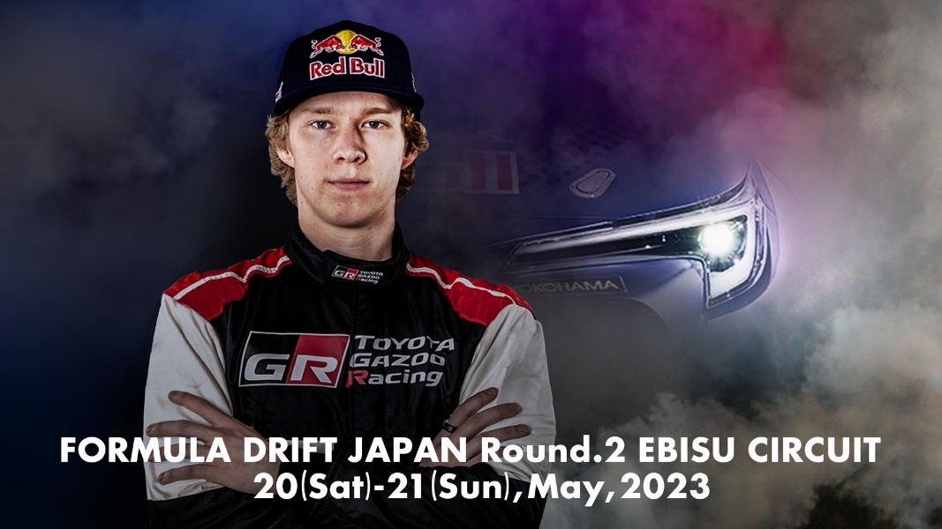
A visual announcing Rovanperä’s participation in FDJ

