17th February 2022

YOKOHAMA to continue supplying tyres for SUPER FORMULA from 2023 and develop racing tyres using sustainable materials

YOKOHAMA announced today that it will continue to supply its ADVAN racing tyres as the control tyre for the Japanese SUPER FORMULA Championship (hereafter, SUPER FORMULA) for the next several years from 2023. YOKOHAMA has served as SUPER FORMULA’s control tyre supplier since 2016. From 2023, the Company plans to supply racing tyres made from sustainable materials. Development of these tyres will begin this year.

The supply of racing tyres made from sustainable materials will be carried out in support of the SUPER FORMULA NEXT50 (SF NEXT50) project announced in October 2021 by Japan Race Promotion Inc. (JRP), which runs the SUPER FORMULA series. The SF NEXT50 project is being promoted with the cooperation of various companies that share the common goal of creating a sustainable motorsports industry by responding to changes in the environment surrounding the automobile and motorsports industries, including the promotion of SDGs and carbon neutrality.

YOKOHAMA has been conducting R&D on sustainable materials for several years and has exhibited its research on technology to produce synthetic rubber from biomass and on recyclable thermoreversible rubber at the Rubber & Elastomer Technology Exhibition held in 2016 and the 46th Tokyo Motor Show in 2019. In its development of racing tyres for SF NEXT50, YOKOHAMA plans to use various naturally derived compounding agents, such as silica produced from rice husks, oil from oil palm fruit nuts, and orange peels. Rubber recycled from scrap tyres also will be used. YOKOHAMA plans to use sustainable materials that will not negatively affect racing car performance. The tyres will be tested during trial runs of the future formula racing car that will be conducted by JRP before and after each SUPER FORMULA race this year, with development of the 2023 control tyre scheduled to be completed by the end of the 2022 SUPER FORMULA season. YOKOHAMA will continue its development of sustainable racing tyres after 2023, with the aim of supplying control tyres in 2025 that have a sustainable material content ratio of 35% or more without any sacrifice in sports performance.

Under YOKOHAMA´s three-year (2021–2023) medium-term management plan YX2023, the consumer tyre business aims to maximize its sale ratios of high-value-added YOKOHAMA tyres, namely the global flagship ADVAN brand, the GEOLANDAR brand of tyres for SUVs and pick-up trucks, and various winter tyres. The plan also positions participation in motorsports activities as crucial to YOKOHAMA’s development of advanced tyre technologies and strengthening of its ADVAN and GEOLANDAR brands. The Company’s development of high-performance and top-quality tyres for new cars and the replacement market benefits from the technologies accumulated through its participation in a wide variety of motorsports events in Japan and around the globe, from top-category races to grassroots races. YOKOHAMA also regards ESG activities as an important strategy that will contribute to the strengthening of its business and lead to sustainable increases in its corporate value. Efforts to realize a circular economy aim to increase the ratio of renewable and recyclable materials used by the Company to more than 30% of total materials used by 2030.

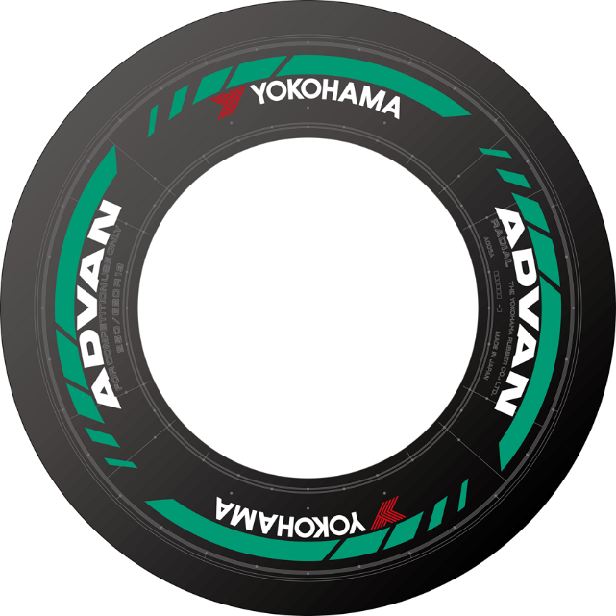
Image of a developmental racing tyre

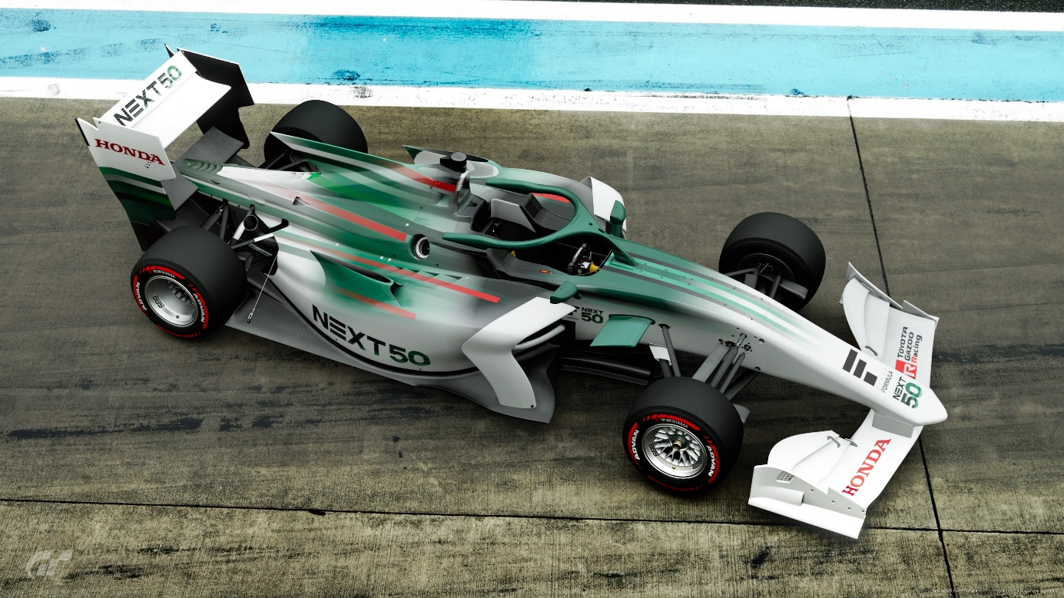
Digital image of an SF NEXT50 test car *Created using PlayStation®4 video game software “Gran Turismo Sport” (C)2019 Sony Interactive Entertainment Inc. Developed by Polyphony Digital Inc.

Comment from Yoshihisa Ueno, President of Japan Race Promotion, Inc.
“We have worked closely with Yokohama Rubber, Inc., over the past several years to take SUPER FORMULA to another level. We are extremely pleased to take on new challenges with them, as part of the SF NEXT50 project. As we work towards the realization of carbon neutral, while at the same time developing racing tyres that place less of a burden on the environment, and from the perspective of our ‘driver’s first’ initiative, we ponder the question “what is the best tyre solution for one of the top races in the world?” We hope it will be a big step forward by developing sustainable racing tyres for the future of motorsport, as well as for the automotive industry on a whole, and from a promoter’s perspective, we also strive to increase both the overall image and value of SUPER FORMULA.”

Comment from Masataka Yamaishi, Yokohama Rubber President and Chairman of the Board
In support of JRP's SF NEXT50 concept for sustainable motorsports activities, Yokohama Rubber will continue to supply the control tyres for SUPER FORMULA races from 2023 while also continuing our effort to develop racing tyres that use sustainable materials. We regard this ESG activity as one of our business activities aimed at maximizing the sales ratio of high value-added products in our consumer tyre business. Yokohama Rubber will be expanding its use of renewable and recyclable raw materials in the future, with the aim of using those materials in our tyres without sacrificing the vehicles driving performance. Toward that end, we look forward to supporting SUPER FORMULA, Japan’s penultimate race series, and to developing and testing tyres under the extreme conditions typical in the races.

A history of YOKOHAMA’s participation in formula racing

Year | Role & Major Achievements
1974 | Began supplying tyres for the All Japan FJ1300 Championship
1979 | Began supplying tyres for the All Japan Formula Pacific Championship
1980 | Began supplying ADVAN racing tyres for the All Japan Formula 2 Championship
1981 | Participated in the All Japan Formula 3 Championship
1982 | Began supplying tyres for the Formula 3 European Championship. Cars equipped with  YOKOHAMA tyres finished first in three races this year and won four races in each of the next  two years.
1982 | ADVAN TOMEI MARCH (822/BMW engine) raced to TEAM ADVAN’s first victory in the All  Japan Formula 2 Championship
1983 | Began supplying control tyre for the Macau Grand Prix, generally considered the decisive round  of the worldwide Formula 3 Championship series, as it often determined the series champion  from among the top-ranked drivers coming from around the world. YOKOHAMA served  as control tyre supplier for 33 years until 2015.
1984 | Future F1 driver Stefan Johansson, driving an ADVAN-equipped machine, finishes first three  times in the All Japan Formula 2 Championship season.
1984 | All Japan Formula 3 Championship series champion
1987 | All Japan Formula 2 Championship replaced by All Japan F3000 Championship. Many drivers,  including Kunimitsu Takahashi, Takao Wada, and Masami Kageyama continue to race in  ADVAN-equipped machines.
1988 | Served as control tyre supplier for the Formula Pacific series in the US
1996 | All Japan F3000 Championship renamed as Formula Nippon
1997 | Withdrawal from Formula Nippon upon its selection of different control tyre
1998 | Served as control tyre supplier for the Spanish Formula 3 Championship
2000 | Served as control tyre supplier for the German Formula 3 Championship
2001 | Served as control tyre supplier for the Australian Formula 3 Championship
2016 | Selected as control tyre supplier for the Japanese SUPER FORMULA Championship, once  again becoming the supplier for a top formula racing series

