17th October 2023

YOKOHAMA to exhibit at Japan Mobility Show 2023

YOKOHAMA announced today that it will participate in the Japan Mobility Show 2023, to be held at Tokyo Big Sight in Koto-ku, Tokyo, from 26th October through 5th November (open to the general public from 28th October). Under the theme "YOKOHAMA: Creating the Tyres of the Future,” the YOKOHAMA booth will introduce EV-compatible technologies and sustainable technologies, as well as other advanced technologies currently under development.

The YOKOHAMA booth will introduce visitors to new technologies and tyres that YOKOHAMA has developed in response to changes in mobility demand stemming from the rise of CASE and MaaS, such as its Intelligent Tyre Mounted Sensor that provides tyres with sensing functionality, high-load, small-diameter tyres for use on vehicles with large interior spaces and low flooring, and self-sealing tyres that prevent punctures. New concept tyres that will be displayed include the ADVAN A50, an aerodynamic fin tyre that contributes to better vehicle performance by controlling the airflow around the tyre, and a concept sports tyre of the future that features both sport and comfort driving modes.

YOKOHAMA’s EV-related technologies will be featured in the first-ever display of the ADVAN Sport EV, a new EV-dedicated high-performance tyre that was launched in Europe this autumn, and the introduction of YOKOHAMA’s development of high load capacity (HLC) tyres that responds to the increasing weight of vehicles, such as EVs and large SUVs. Sustainability-related technologies will be highlighted in the display of a tyre with a sustainable materials composition ratio of approximately 33%. This tyre is being supplied as the control tyre for this year’s Japanese SUPER FORMULA Championship series. The YOKOHAMA booth also will introduce visitors to HAICoLab*, YOKOHAMA’s proprietary AI-based development framework being used to develop new materials and tyres.
* An acronym for Humans and AI ColLaborate for digital innovation

The YOKOHAMA booth will be located in the Tokyo Big Sight’s East Exhibition Halls’ East Hall 2.
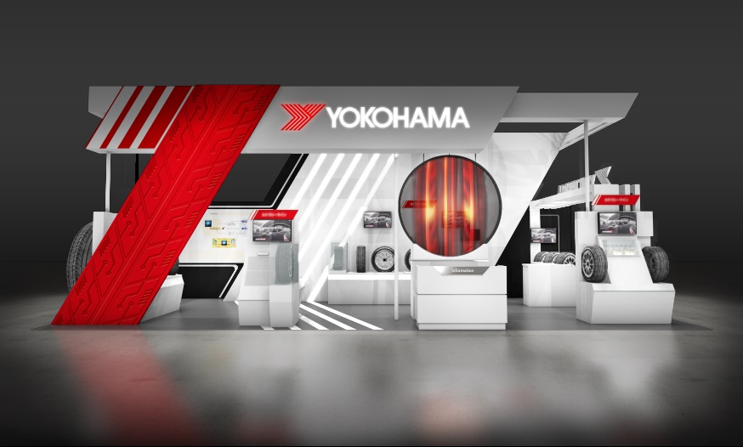

Image of the YOKOHAMA booth

