YOKOHAMA to participate at Europe’s Biggest Tyre Trade fair

The Japanese Tyre Manufacturer YOKOHAMA will have a strong presence at the forthcoming “Reifenmesse” Tyre trade fair to be held in Essen, Germany between 5th to 8th June 2012.
YOKOHAMA’s BluEarth concept created to provide fuel saving tyres which are environmentally and social friendly, without compromising on aspects of high performance and comfort will have a prominent place at the fair.
In Essen, YOKOHAMA will present a range of its latest products that include its flagship eco tyre BluEarth-1, the environmentally friendly and fuel saving BluEarth AE01 Tyre, a mass market tyre which is now available in Europe and incorporates the technology developed with the BluEarth concept. Natural orange oil and a nano blend technology in its compound form the essence of this tyre which provides fuel saving benefits as well as safety on wet and long mileage in addition to being lightweight and offering low external noise.
The properties of the BluEarth family are also incorporated into the OE fitment in some sizes of the Advan Sport V105 providing the perfect balance of sport and comfort, with fuel saving properties, OE approved quality, low external noise and excellent wet performance and will also be showcased. In fact the latest development for this tyre is it is already being fitted in the Mercedes Benz SLK as Original Equipment.
YOKOHAMA will also display the Geolandar G055, the urban SUV which provides a passenger car like performance including enhanced grip and handling, fuel saving, low noise and high durability. In addition to these products, the YOKOHAMA booth will also display the winter products lineup as well as the C.drive2, and S.drive. The Advan Neova AD08 will complete the lineup within the passenger car category.
Truck and Bus Tyre Products from the Zenvironment concept will also be on show. The Zenvironment concept proves that technology can simultaneously enhance performance while delivering superior fuel economy and durability.
The largest YOKOHAMA product on display will be an OTR tyre, the RB31 which has been especially developed for articulated dump trucks.
Visitors to the booth will also be able to learn about the new EU Labelling requirement for Tyres, as well as get first hand knowledge of YOKOHAMA’s projects, environmental and social actions and general corporate information from various European distributors and representatives of YOKOHAMA.
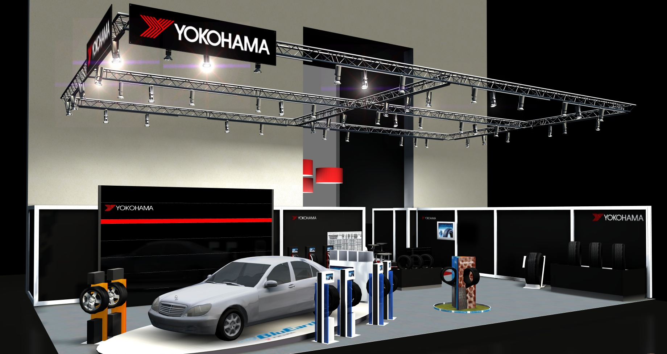

Notes to Editors
YOKOHAMA is one of the leading Tyre manufacturers in the world and is Official Tyre supplier for;
FIA World Touring Car Championship (WTCC) – since 2006
European Touring Car Cup (ETCC) – since 2005
Intercontinental Rally Challenge (IRC) – since 2007
Scandinavian Touring Car Championship (STCC) – since 2010
Russian Touring Car Championship (RTCC) – since 2006
Chinese Touring Car Championship (CTCC) – since 2010
Irish Touring Car Championship (ITCC) – new for 2012
International Formula 3 Grand Prix Macau – since 1983
ATS German Formula 3 – until 2005 and since 2007
FIA F2 Championship – new for 2012
Japanese Formula 3 – since 2011
ADAC GT Masters – new for 2012

