17th February 2023

YOKOHAMA to expand passenger car tyre capacity in India to 4.5 million tyres

YOKOHAMA announced today that it is expanding passenger car tyre production capacity in India to meet the increasing demands from the local market. With an additional investment of US$82 million, the company looks to increase its annual passenger car tyre production capacity in India with Yokohama India Pvt. Ltd. (YIN), its local passenger car tyre manufacturing and sales subsidiary, from the current 2.8 million to 4.5 million tyres. This new capacity will be installed within premises of the Visakhapatnam Plant* in the eastern part of India. The new line is scheduled to start production in the fourth quarter of 2024 and will be capable of building passenger car tyres up to 22 inches.

YIN has been in operation since 2007 and has contributed to a sharp increase in sales of YOKOHAMA branded tyres in the Indian market. The tyres sold in India are specifically designed for Indian driving conditions. By producing quality tyres that meet local market needs and expanding its sales channel, YIN has grown rapidly and has made India one of YOKOHAMA’s most important markets.

India’s automobile industry has been expanding rapidly, with its total automobile sales volume in 2022 surpassing that of Japan, making India the third largest automobile market in the world. YOKOHAMA expects this growth to continue in the future. To support this growth, the company has steadily expanded YIN’s annual production capacity - from an initial 700,000 tyres in 2014 to 1.53 million in 2019 and 1.96 million in 2021. From January 2023, YIN has been operating its plant at an annual capacity of 2.8 million.

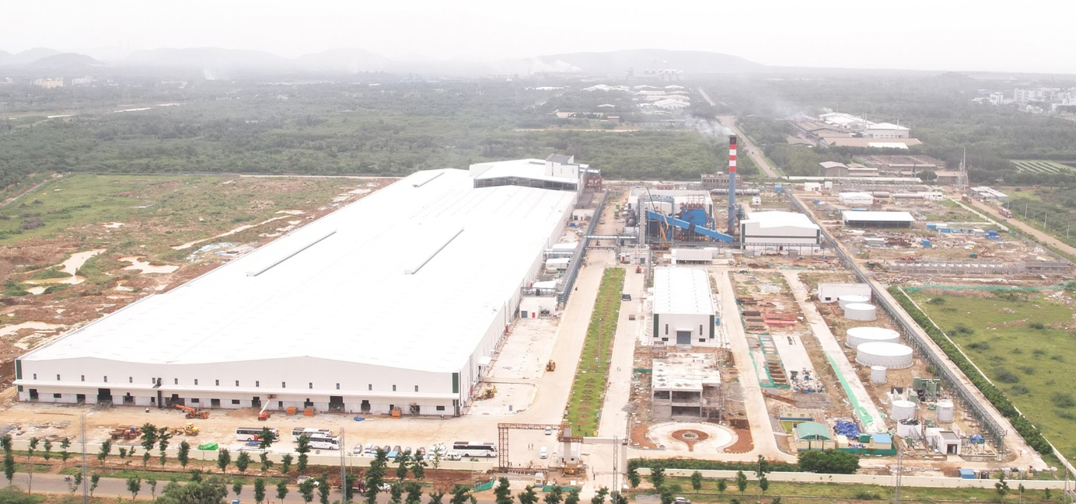
Visakhapatnam Plant
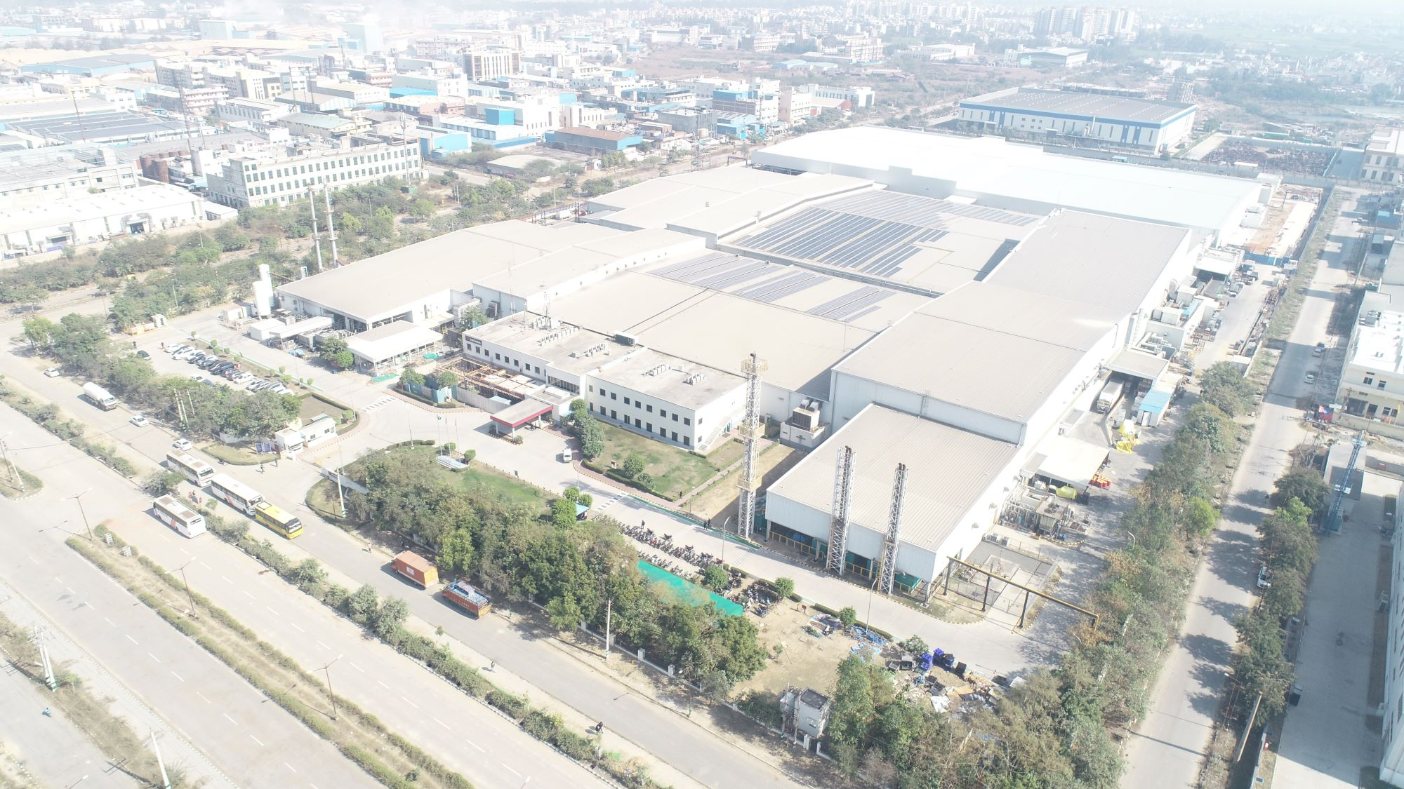
Yokohama India

Outline of Yokohama India Pvt. Ltd.
Head office | Bahadurgarh Industrial Estate, Haryana, India
Established | April 2007
Business | Manufacture and sale of replacement tyres for passenger cars and original equipment  tyres for car manfacturers
Plant location | Bahadurgarh Industrial Estate, Haryana, India
Plant startup date | July 2014
Production capacity | 2.8 million tires per year
Plant site area | Approx. 100,000 square meters

*Outline of Visakhapatnam Plant
Company name | ATC Tires AP Pvt. Ltd. (a YOHT group company)
Location | Atchutapuram Industrial Park, Visakhapatnam, Andhra Pradesh, India
Site area | Approx. 390,000 square meters
This new plant was started up in August 2022 to boost the production capacity of Yokohama Off-Highway Tyres (YOHT), a YOKOHAMA subsidiary engaged in the production and sale of tyres for agricultural equipment and other off-highway tyres (OHT).

