17th February 2022

YOKOHAMA to expand production capacity for high-pressure hydraulic hoses at its Ibaraki Plant

YOKOHAMA announced today that it will expand the production capacity of its Ibaraki Plant (Omitama City, Ibaraki Prefecture), where the Company manufactures high-pressure hydraulic hoses. The capacity addition will focus on installing a new line for spiral wire hoses used mainly
in construction machinery and increase the production capacity of the Ibaraki Plant’s continuous production lines* by 1.5 times. Construction will begin this May, with the new line expected to start operating in September 2023. The total planned capital investment is ¥700 million. This investment will expand the types of hoses manufactured on continuous production lines to large diameter hoses while also utilizing the capacity of the existing production line for other products.
* Automated production lines that connect various production processes

Demand for construction machinery temporarily declined owing to the impact from the coronavirus pandemic, but it has since recovered sharply, especially outside of Japan, and is expected to continue increasing. YOKOHAMA also in the midst of expanding the spiral wire hose capacity of Yokohama Industrial Products – Hangzhou Co., Ltd. (Hangzhou City, Zhejiang Province), the Group’s high-pressure hydraulic hose production base in China, where production capacity will be nearly tripled by this September. To meet expected further increases in demand in coming years, Yokohama Rubber now has decided to also invest in expansion at its Ibaraki Plant in Japan.

YOKOHAMA is currently implementing Yokohama Transformation 2023 (YX2023), the Company’s medium-term management plan for fiscal years 2021–2023. Under this plan, the Company aims to enhance the MB segment’s growth potential and make it a source of stable earnings by concentrating the segment’s resources in its two strongest businesses - hose & couplings and industrial products.

Profile of Ibaraki Plant
Established | 1973
Location | 1 Hatori-Nishi, Omitama City, Ibaraki Prefecture, Japan
Site Area | 152,000m2
Business | Production of high-pressure hoses

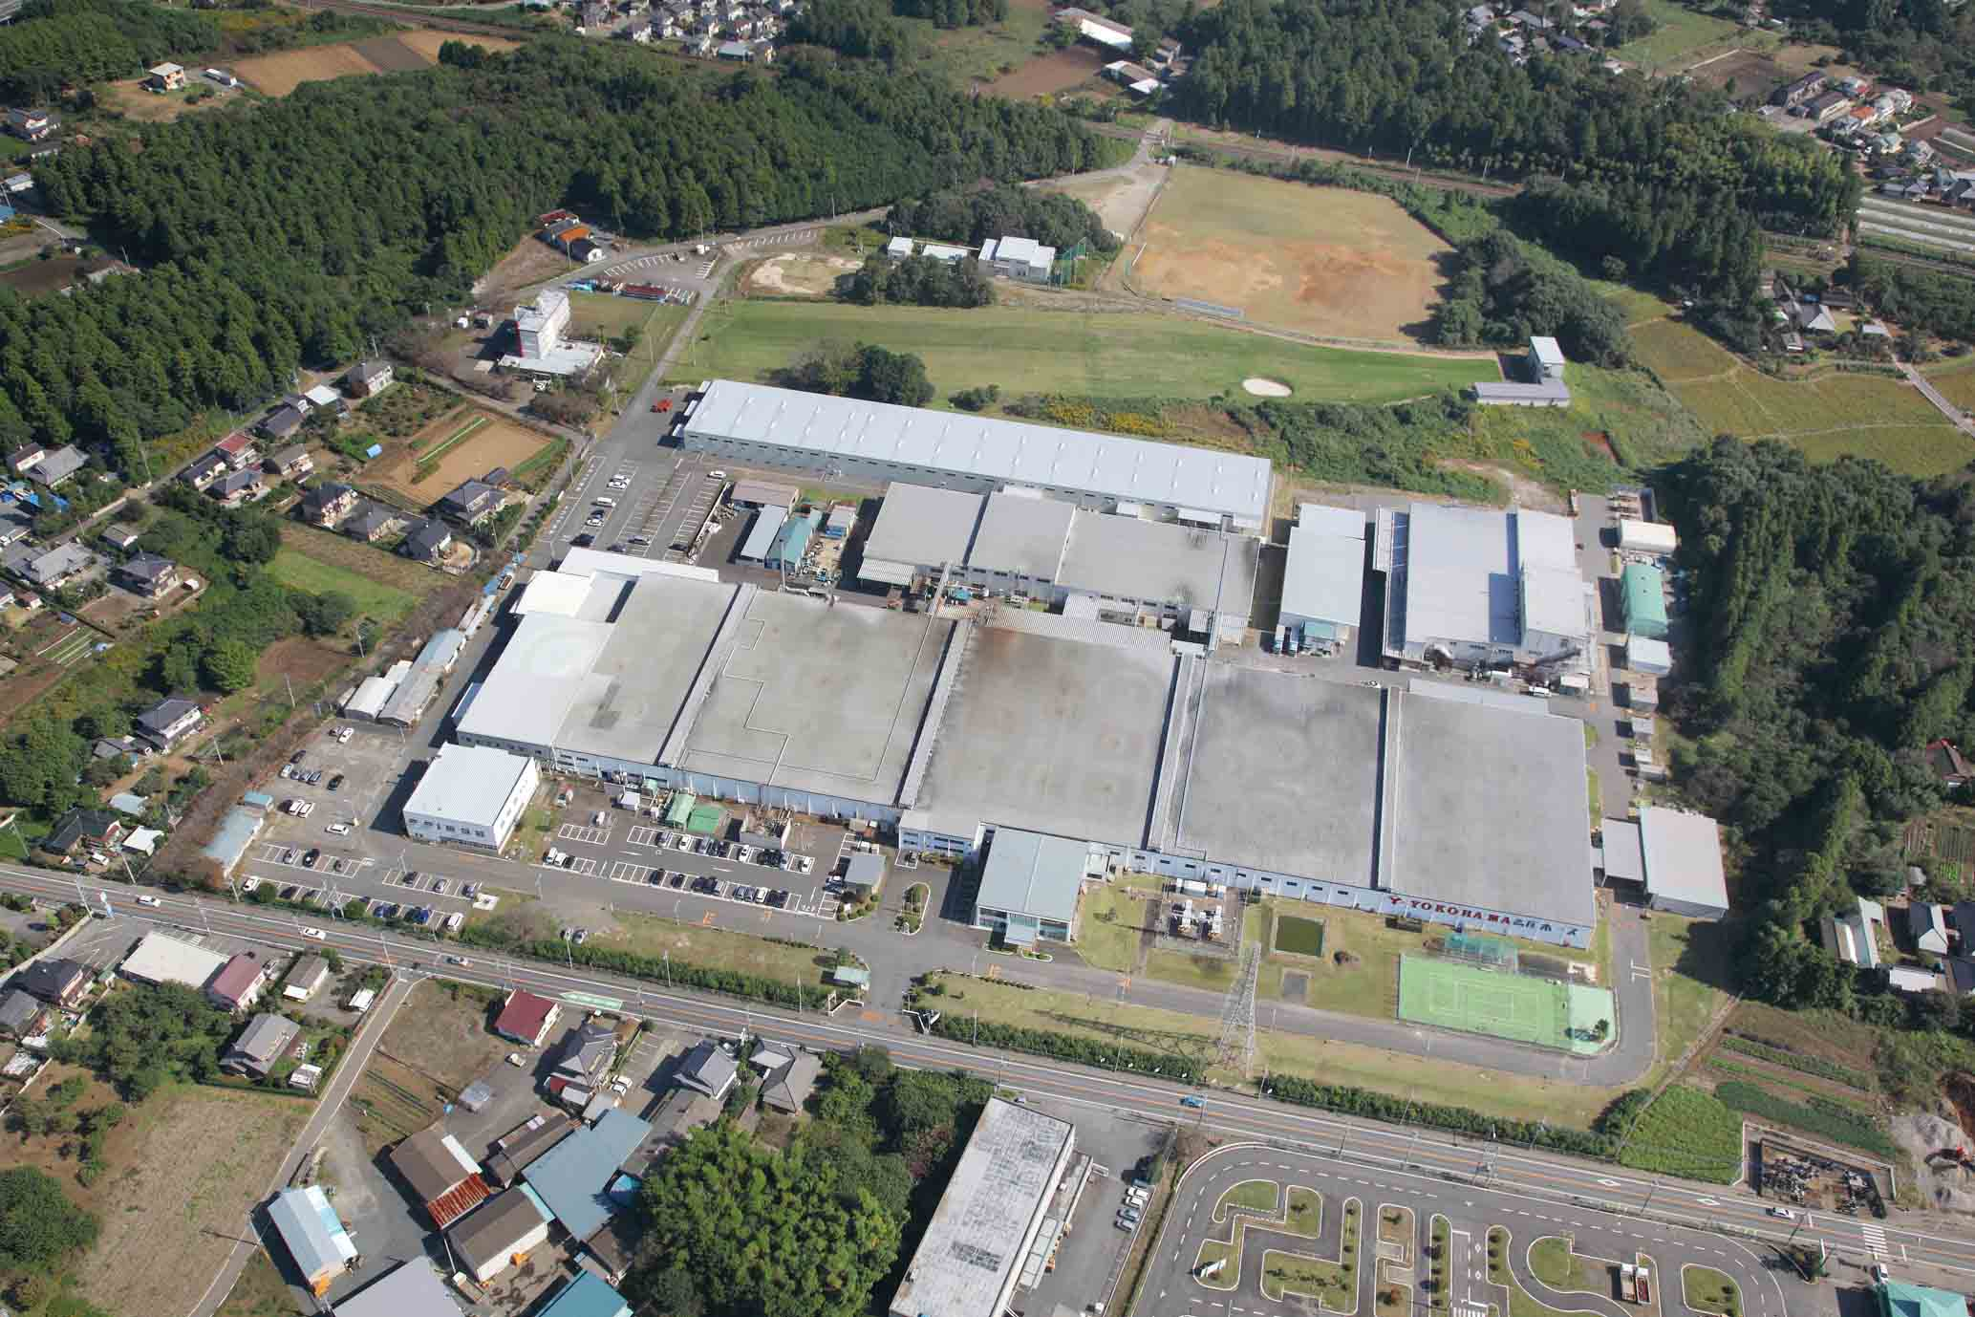
Ibaraki Plant

