21st February 2022

YOKOHAMA to introduce ADVAN Sport V107 via global online event produced from Japan and Germany

YOKOHAMA announced today that it will stream an online event introducing its new global flagship tyre, the ADVAN Sport V107. Preceding the tyre’s successive release in major markets around the world from this March, the event will introduce the tyre’s development story and testing at YOKOHAMA’s Nürburgring Test Centre in Germany. The contents are designed to increase global understanding and interest in ADVAN Sport V107 and the YOKOHAMA tyre brand. The event will be streamed from 12pm on 24th February (CET) on the ADVAN Sport V107 dedicated website:
https://www.y-yokohama.com/brand/tire/advan/v107lp/

The online video event will be produced at a studio in Japan with a live link from Nürburgring, Germany. It will be moderated by radio DJ and narrator Sascha in Japan with female racing driver and Europe race presenter Eve Scheer joining from Germany. In addition to the ADVAN Sport V107 product description and development story, the event will provide viewers with an inside look at YOKOHAMA’s Nürburgring Test Centre and the tyre’s evaluation by YOKOHAMA test drivers at Nürburgring. Other contents will include an interview with Jörg Müller, former BMW Works driver and current participant in the Nürburgring 24-hour Endurance Race; former F1 driver Ukyo Katayama’s impressions of the ADVAN Sport V107; and a talk show featuring Jörg Müller and the test drivers.

The ADVAN Sport V107 has been developed for use on premium high-performance cars, premium high-performance SUVs, and premium electric vehicles (EVs). Following joint development projects with leading premium car manufacturers and testing at YOKOHAMA’s test centre at the Nürburgring, widely considered the world’s most demanding racetrack, delivery of special OE ADVAN Sport V107 tyres began in 2020, including tyres for Mercedes-AMG and BMW M premium cars.

Under YOKOHAMA’s three-year (2021–2023) medium-term management plan, Yokohama Transformation 2023 (YX2023), the consumer tyre business aims to maximize the sales ratios of high-value-added YOKOHAMA tyres, namely the global flagship ADVAN brand, the GEOLANDAR brand of tyres for SUVs and pick-up trucks, and various winter tyres. In 2022, the Company plans to strengthen sales of ADVAN brand summer tyres by launching the ADVAN Sport V107, as well as its new high-performance street sports tyre, the ADVAN NEOVA AD09, being introduced in Japan in February 2022 and gradually being expanded to Asia and North America.
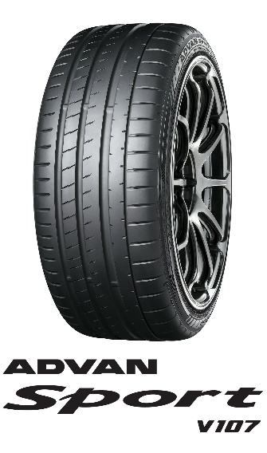
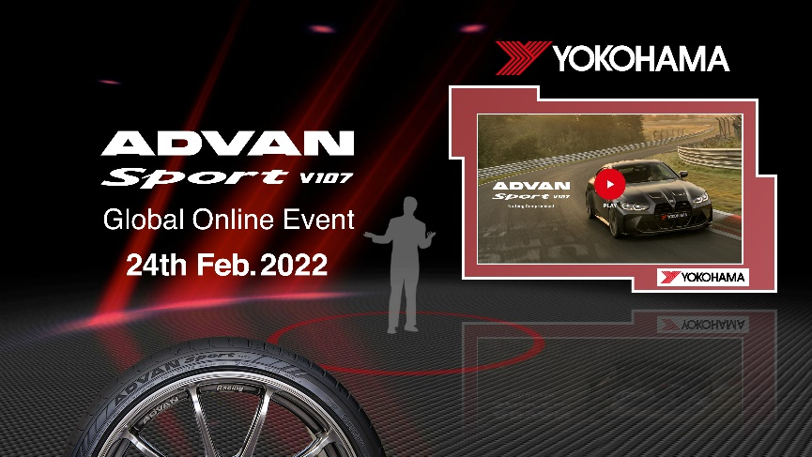
Website Event Announcement

