12th July 2023

YOKOHAMA to introduce new ADVAN Sport EV, an ultra-high performance summer tyre for electric vehicles

YOKOHAMA announced today that it will introduce the ADVAN Sport EV, a new ultra-high performance summer tyre for electric vehicles (EVs), to overseas markets including Europe from this autumn. YOKOHAMA plans to offer the new tyre in 16 sizes.

The ADVAN Sport EV is an ultra-high performance summer tyre for premium EVs. Based on YOKOHAMA’s ADVAN Sport V107 tyre for high-performance cars, the new ADVAN Sport EV was developed to contribute to the low electricity consumption and quietness desired by owners of EVs and other electrified vehicles. The new ADVAN Sport EV features technologies cultivated in YOKOHAMA’s development of original equipment (OE) tyres already being supplied for premium EVs and other electrified vehicles from such premium car makers as BMW and Mercedes-AMG.

One of those technologies is a compound proven to reduce tyre rolling resistance, thereby expanding EV driving range, which contributes to low electricity consumption. The compound also enhances the tyres’ wet performance, contributing to safe driving on wet roads. ADVAN Sport EV tyres’ sidewalls will feature the letters “SILENTFOAM”, indicating that YOKOHAMA’s SILENTFOAM, a specially designed polyurethane foam, is attached to the inside of the tyre. This polyurethane foam reduces tyre cavity resonance (the sound created inside the tyre as it vibrates while running over uneven road surfaces), thereby eliminating unpleasant noise in the passenger cabin and contributing to a quiet ride. The ADVAN Sport EV’s tread pattern is the same design used on YOKOHAMA’s ADVAN Sport V107, marketed as an OE tyre and replacement tyre for high-performance cars.

The ADVAN Sport EV also will be the first YOKOHAMA tyre to bear the company’s new proprietary “E+” mark, which will be on tyres sold for use on electrified vehicles. In addition to being displayed on the sidewall of YOKOHAMA tyres that incorporate technologies that meet the special needs of electrified vehicles, such as low electricity consumption and quietness, the “E+” mark will be prominently displayed in tyre catalogues and websites to facilitate customers’ tyre selection.

Under YOKOHAMA’s three-year (2021–2023) medium-term management plan, Yokohama Transformation 2023 (YX2023), the consumer tyre business aims to maximize the sales ratios of high-value-added YOKOHAMA tyres, namely the global flagship ADVAN brand, the GEOLANDAR brand of tyres for SUVs and pick-up trucks, and various winter tyres. Key initiatives under this strategy include accelerating the development of ADVAN and GEOLANDAR tyres and expanding their adoption as original equipment on new cars.
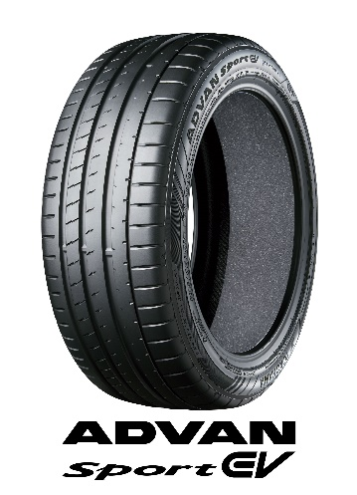
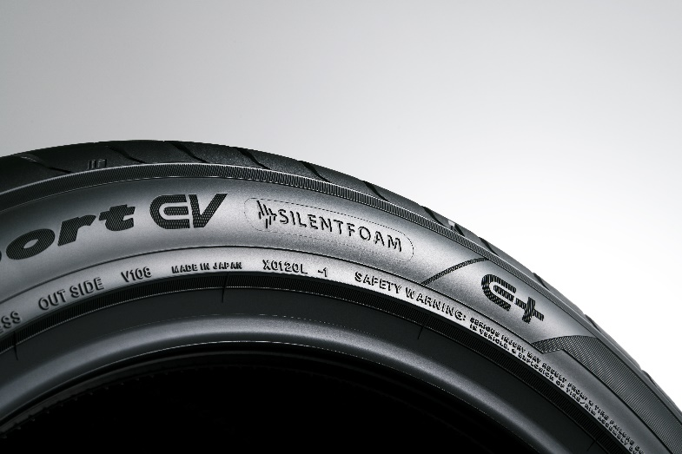
“E+” mark
“SILENTFOAM” and “E+” on an ADVAN Sport EV’s sidewall

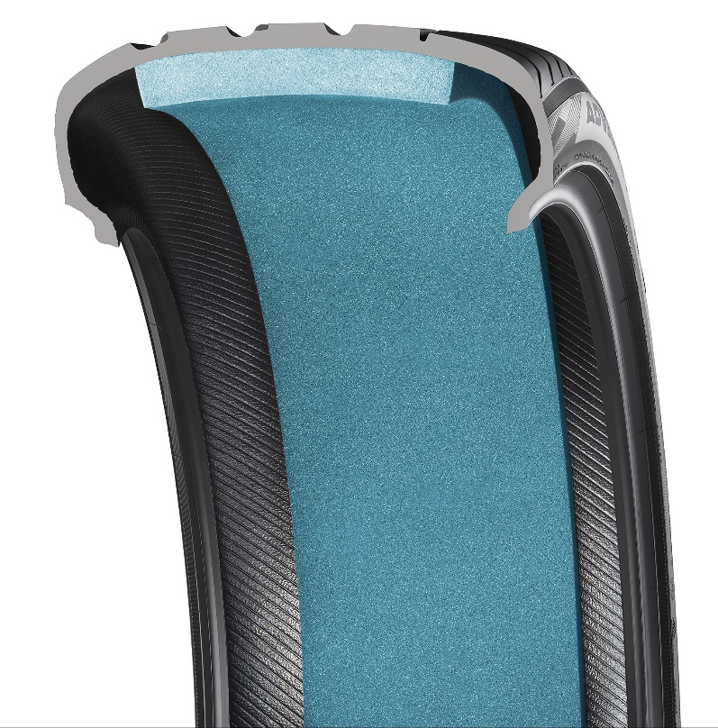
Image of the compound used in ADVAN Sport EV tyres
Image of SILENTFOAM polyurethane foam attached to the tyre’s inside surface (blue coloring is for imaging purpose only)

