9th December 2021

YOKOHAMA to launch new flagship tyre the ADVAN Sport V107

YOKOHAMA announced today that it will launch its ultra-high performance ADVAN Sport V107 as its new global flagship tyre from Spring 2022. Sales will be launched successively in major markets around the world. The Company plans to introduce 30 replacement tyre sizes, ranging from 305/35R23 111Y XL to 225/40ZR18 92Y XL, in Spring 2022, increasing the ADVAN Sport V107 size line-up, including original equipment (OE) sizes for new cars, to 43 sizes. The size line-up will be expanded gradually thereafter to 80 sizes, including OE tyres, by the end of 2022.

ADVAN is the YOKOHAMA tyre global flagship brand. Its line-up of outstanding, high-performance tyres and their use as OE on many of the world’s leading premium cars as well as in motorsports events around the world have raised global recognition of the YOKOHAMA tyre brand. The ADVAN Sport V107 will succeed the ADVAN Sport V105 as YOKOHAMA’s global flagship ultra-high-performance tyre. The ADVAN Sport V107 has been developed for use on premium high-performance cars, premium high-performance SUVs, and premium electric vehicles (EVs). Following joint development projects with leading premium car manufacturers and testing at YOKOHAMA’s test centre at the Nürburgring, widely considered the world’s most demanding racecourse, delivery of special OE ADVAN Sport V107 tyres began in 2020, including tyres for Mercedes-AMG and BMW M premium cars. YOKOHAMA is now launching replacement tyres based on these earlier developed OE tyres and will expand the available sizes to create a full commercial line-up of ultra-high performance ADVAN Sport V107 tyres.
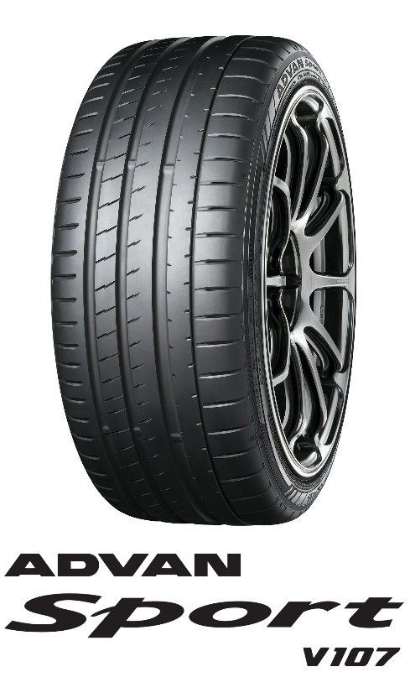

While following the ADVAN Sport V105 concept of providing a perfect balance of driving performance combined with superior comfort and safety characteristics, the new tyre’s dry/wet performance and steering stability surpass the high levels achieved by its predecessor. The tyre’s special asymmetric tread pattern contributes to its ability to deliver the variable performance required from the tread’s inner and outer sides, and its rubber compound incorporates technologies cultivated during the development of OE versions of the tyre for leading premium car manufacturers. Together, these two features deliver a strong grip on dry and wet road surfaces. The ADVAN Sport V107 applies the cutting-edge matrix body-ply structure used in its predecessor. It also is YOKOHAMA’s first replacement tyre to incorporate the Company’s unique power crown belt cover* structure that uses a high-rigidity aramid fiber as well as a newly improved mound profile that strengthens the tyre’s gripping power. These new design features have dramatically increased the tyres’ contribution to the excellent steering stability and comfort at high speeds that are essential qualities for high-power premium cars. The tyre’s sidewall features a new stylish dark design that provides the logo visibility and upscale image appropriate for a global flagship tyre. In addition, the letters “SUV” are inscribed on the sidewall of SUV-size tyres. In February 2022, YOKOHAMA
plans to hold a series of online events around the world to demonstrate the many appealing features of its new ADVAN Sport V107 tyres.
*Used only on certain size tyres

Under YOKOHAMA’s three-year (2021–2023) medium-term management plan, Yokohama Transformation 2023 (YX2023), the consumer tyre business aims to maximize the sales ratios of high-value-added YOKOHAMA tyres, namely the global flagship ADVAN brand, the GEOLANDAR brand of tyres for SUVs and pick-up trucks, and various winter tyres. In 2022, the Company plans to strengthen sales of ADVAN brand summer tyres by launching the ADVAN Sport V107, as well as its new high-performance street sports tyre, the ADVAN NEOVA AD09.

Available Sizes
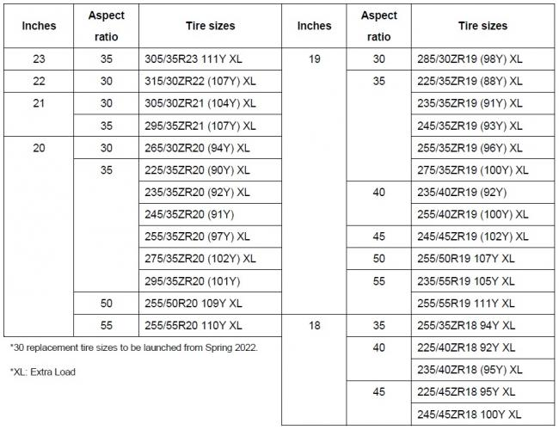

ADVAN Sport V107 is achieved with outstanding steering precision road handling and high levels of reactivity. Increasing the grip with the road, giving driver an incredible ride with precise control and road holding.

(1) “Asymmetric tread pattern” offers excellent grip on both dry and wet conditions
(2) “Power crown belt cover” by using highly rigid aramid fiber improves steering stability on dry roads
(3) “New compound” jointly developed with one of the world’s leading automakers

The new structure equipped with proprietary “Power crown belt cover”
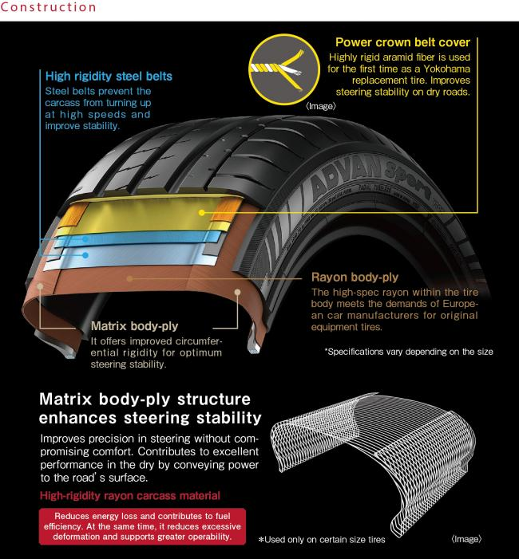
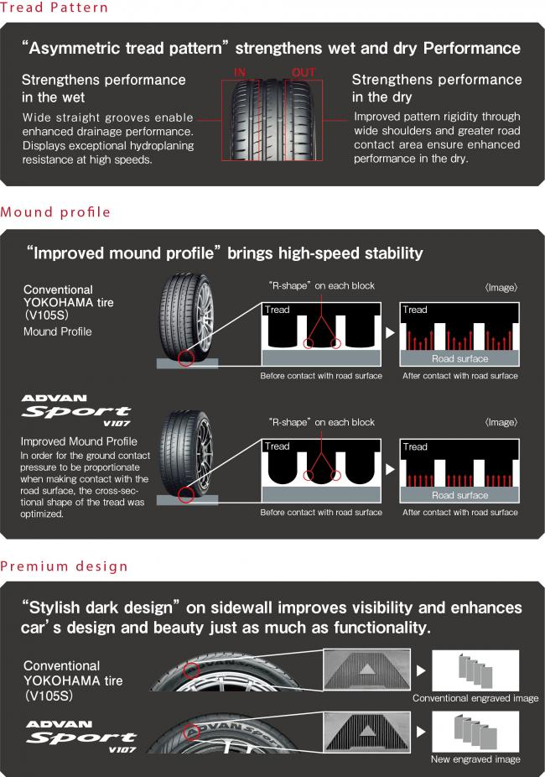

The special new compound for V107
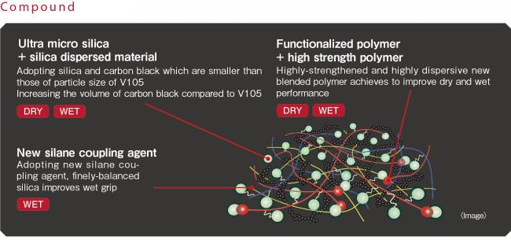

Expanded road contact area offers stronger grip
