5th May 2024

**YOKOHAMA to launch the GEOLANDAR A/T4, a new standard all-terrain tyre for SUVs and pick-up trucks that enhances the off-road driving sensation**

YOKOHAMA today introduces the GEOLANDAR A/T4, a standard all-terrain tyre with an aggressive design that enhances the off-road driving sensation. The latest addition to the GEOLANDAR brand of tyres for SUVs and pick-up trucks, the GEOLANDAR A/T4 will be launched successively in markets around the world from mid-2024. YOKOHAMA plans to provide the new tyre in 64 LT- and C-metric sizes and gradually expand the size line-up in the future.

The successor to the GEOLANDAR A/T G015, YOKOHAMA’s previous standard all-terrain tyre, the GEOLANDAR A/T4 is the fourth generation of the GEOLANDAR A/T series first introduced in 1996. In addition to enhancing the on-road and off-road performance required of all-terrain tyres, the new GEOLANDAR A/T4 features a design with a stronger off-road image. An aggressive tread pattern and the sidewall’s block design enhance the off-road driving sensation while also improving off-road performance and resistance to cuts and chipping. The new GEOLANDAR A/T4’s design also provides excellent wet performance and comfort during on-road driving. In addition, the revised shape of the tyre’s contact patch further enhances its off-road performance while also improving on-road wear resistance. The new design also improves the new GEOLANDAR standard all-terrain tyre’s performance on snow, and all sizes in the line-up have received the Three-Peak Mountain Snowflake Symbol* applied to tyres that meet international standards for tyres to be used in severe snow.

*\* The Three-Peak Mountain Snowflake Symbol is a mark certifying winter tyres for use in Europe and North America.*

In response to the increasing global popularity of SUVs and pick-up trucks, YOKOHAMA is expanding its GEOLANDAR brand to include tyres suitable for use on a wide range of road surfaces, from highway terrain to mud terrain, with extensive size line-ups sizes for each GEOLANDAR model. In addition to the new all-terrain GEOLANDAR A/T4, the diverse GEOLANDAR brand line-up includes the GEOLANDAR X-AT for drivers who want to tune and dress up their vehicles for off-road driving and the GEOLANDAR A/T XD being sold in North America and Australia for use on large commercial vehicles, including full-size pick-up trucks.

The consumer tyre strategy in YOKOHAMA’s new three-year (2024–2026) medium-term management plan, Yokohama Transformation 2026 (YX2026), aims to maximize the sales ratios of high-value-added tyres by expanding sales of YOKOHAMA’s global flagship ADVAN brand, the GEOLANDAR brand of tyres for SUVs and pick-up trucks, winter tyres, and 18-inch and larger tyres. Under the new medium-term plan, YOKOHAMA’s consumer tyre business also is continuing to implement its “Product and Regional Strategies” focused on strengthening the development, supply, and sales of tyres that respond to specific trends in each regional market.

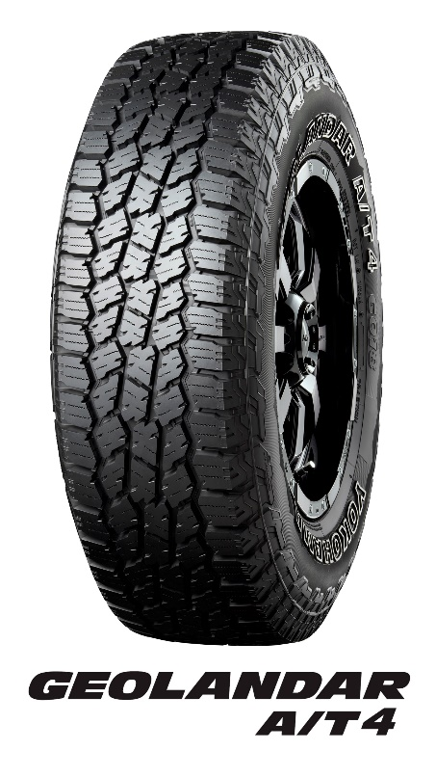

Ein Bild, das Text, Karte Menü, Dokument, Zahl enthält.

**GEOLANDAR A/T 4 design enhances tyre’s on- and off-road performance with an aggressive appearance**

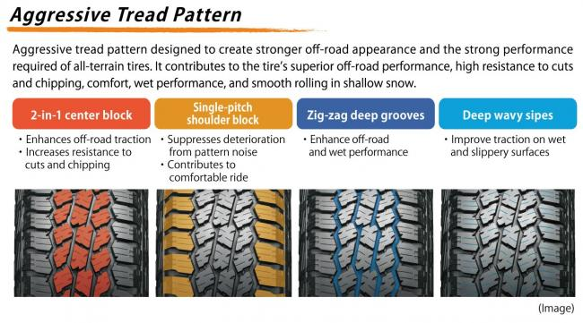

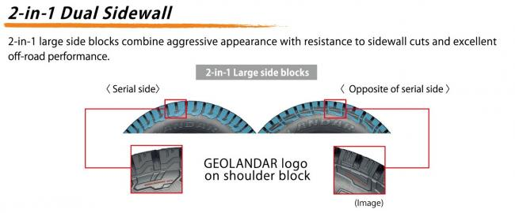

**Contact patch’s shape improves off-road performance and resistance to uneven wear**

