10th March 2022

YOKOHAMA to participate in The Mint 400, an off-road race in USA

YOKOHAMA announced today that vehicles fitted with its GEOLANDAR M/T G003 mud-terrain tyres for SUVs and pickup trucks will be participating in The Mint 400, an off-road race to be held in Nevada, USA, from March 9 to March 13. The GEOLANDAR-equipped vehicles will be driven by world-class off-road racers including Justin Lofton, Ikuo Hanawa, Kristen Matlock and Wayne Matlock.

The Mint 400, the oldest off-road race in America, is a gruelling race over a 400-mile (about 644km) desert course near the foothills outside Las Vegas. More than 450 teams from all over the world participate each year, and more than half of those retire before crossing the finish line.

GEOLANDAR M/T G003 tyres deliver superior performance on the full range of off-road surfaces over an exceptionally long lifespan. In addition, the tyre features a sturdy and aggressive design that enhances the off-road driving sensation. YOKOHAMA’s GEOLANDAR tyres have demonstrated their superior off-road performance in many races over the years, including a one-two finish in the 4800 class at the 2021 King Shocks Area BFE Beatdown and a first-place finish in the Trick Truck class of the 2021 King Shocks Laughlin Desert Classic - both races held in the United States.

Under YOKOHAMA’s three-year (2021–2023) medium-term management plan, Yokohama Transformation 2023 (YX2023), the consumer tyre business aims to maximize the sales ratios of high-value-added YOKOHAMA tyres, namely the global flagship ADVAN brand, the GEOLANDAR brand of tyres for SUVs and pick-up trucks, and various winter tyres. YX2023 also positions participation in motorsports activities as crucial to the company’s effort to develop new tyre technologies that will further strengthen the ADVAN and GEOLANDAR brands. YOKOHAMA therefore is again participating in a wide variety of motorsports events in Japan and around the globe, from top-category to grassroots events.
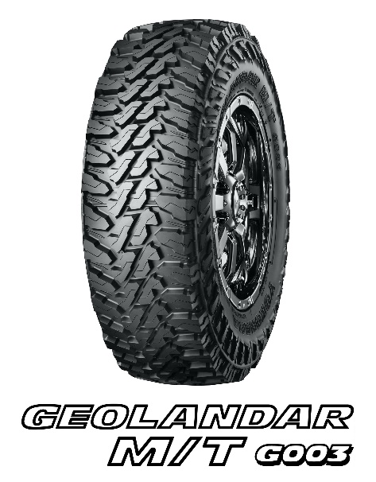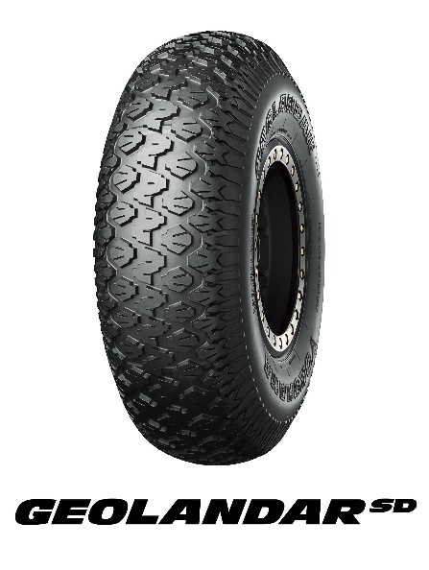
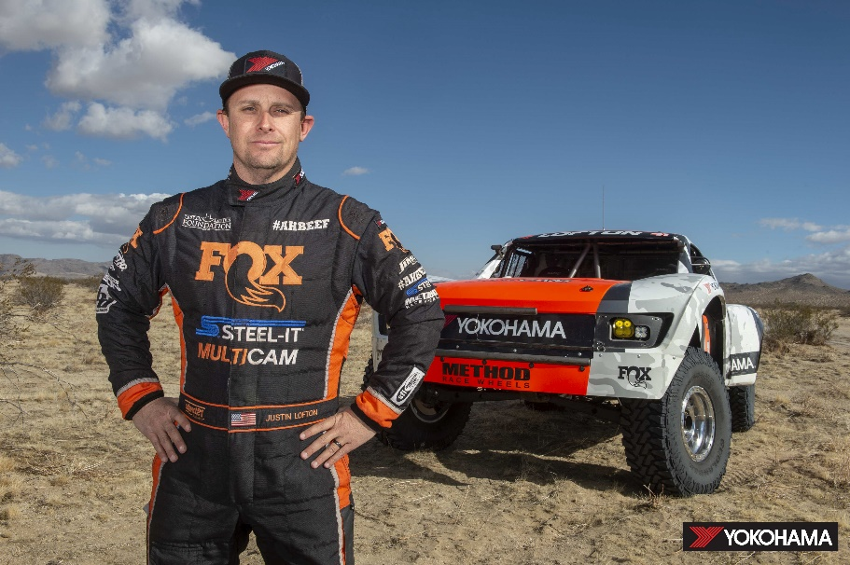
Driver | Justin Lofton
Class | Unlimited Truck
Tyre | 39x13.50R17  GEOLANDAR M/T G003

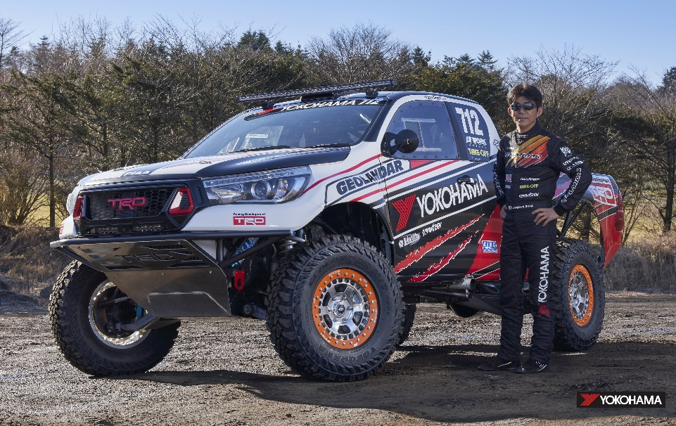
Driver | Ikuo Hanawa
Class | Class 7
Tyre | LT285/75R17  GEOLANDAR M/T G003

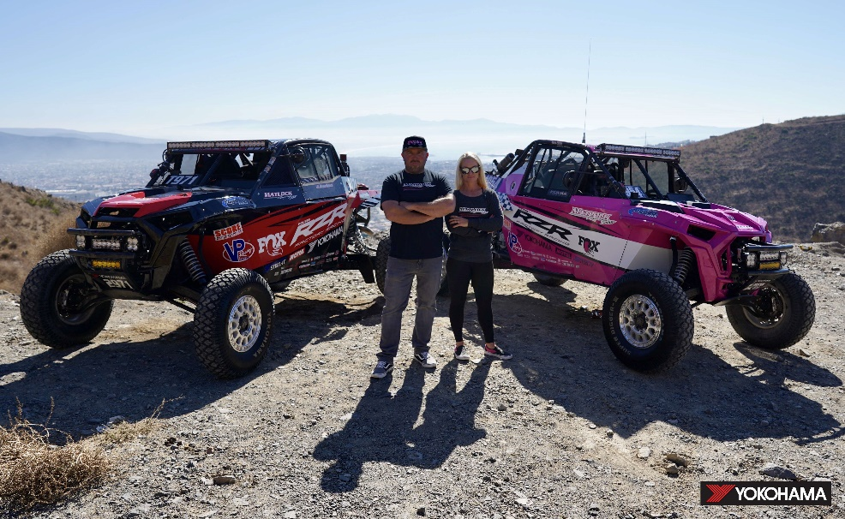
Driver | Kristen Matlock / Wayne Matlock
Class | UTV PR-100
Tyre | 33x10.50-15  GEOLANDAR SD

Mint 400 Entry (other)
Class | Vehicle # | Driver | Tyre
Trophylite | 6081 | Larry Schmueser | 33x12.50R15  GEOLANDAR M/T G003
 | 6031 | Jeremy Crandall
 | 6006 | David Carey
 | 6066 | Josh Cobb
 | 6069 | Jeff Kay
 | 6075 | Chad Woodruff
 | 6025 | Dillon Jensen

