6th April 2023

YOKOHAMA to participate in this year’s Nürburgring 24-Hour Race with two ADVAN-coloured cars

YOKOHAMA s pleased to announce that once again this year it will be participating in the Nürburgring 24-Hour Race (the ADAC TotalEnergies 24h Nürburgring), to be held on 18th- 21st May* in Germany. As part of this year’s ADVAN CHALLENGE that seeks to maximize sales of ADVAN tyres during the global flagship brand’s 45th year, YOKOHAMA will be supplying its ADVAN racing tyres to two cars featuring ADVAN colours that will be aiming to win the overall championship. YOKOHAMA will supply the cars with ADVAN A005 tyres for dry conditions and ADVAN A006 tyres for wet conditions.
*Qualifying races to be held on 22nd-23rd April

YOKOHAMA will be supporting two SP9 Pro class BMW M4 GT3 cars entered by Walkenhorst Motorsport, a BMW’s customer racing team. The two cars’ drivers include Christian Krognes, a four-time podium finisher in last year’s Nürburgring Endurance Series (NLS), the early rounds of which are positioned as preludes to the Nürburgring 24-Hour Race. The other drivers are Jakub Giermaziak, Andy Soucek, Jake Dennis, Thomas Neubauer, Jesse Krohn, and Jens Klingmann.

YOKOHAMA also is supplying its ADVAN racing tyres to the teams participating in the NLS, and one of the two ADVAN-coloured cars was the overall winner in its first appearance* in the NLS second round race.
*In addition to their participation in NLS Round 2, the ADVAN-coloured cars will be racing in NLS Round 3 as well as the Nürburgring 24-Hour qualifying race and the final race.

The Nürburgring 24-Hour Race is held on Germany’s Nürburgring circuit, one of the world’s most challenging race circuits. Each year, the race also is an event that features strong competition among the world's leading tyre manufacturers. By achieving excellent strong results in this race, YOKOHAMA can demonstrate the excellent performance of its ADVAN tyres and strengthen its brand power. The Company has been supporting teams participating in this race for many years, and cars running on YOKOHAMA tyres have won the overall championship three times.

Under YOKOHAMA’s three-year (2021–2023) medium-term management plan, Yokohama Transformation 2023 (YX2023), the consumer tyre business aims to maximize the sales ratios of high-value-added YOKOHAMA tyres, namely the global flagship ADVAN brand, the GEOLANDAR brand of tyres for SUVs and pick-up trucks, and various winter tyres.YX2023 also positions participation in motorsports activities as crucial to the company’s effort to develop new tyre technologies that will further strengthen the ADVAN and GEOLANDAR brands. YOKOHAMA therefore is again participating in a wide variety of motorsports events in Japan and around the globe, from top-category to grassroots events.

Team : Walkenhorst Motorsport
Class : SP9 Pro
Car : BMW M4 GT3
Drivers : Christian Krognes, Jakub Giermaziak, Andy Soucek, Jake Dennis, Thomas Neubauer, Jesse Krohn, Jens Klingmann
Tyres : ADVAN A005 (slick) Sizes: Front 300/680R18 Rear 330/710R18 / ADVAN A006 (rain) Sizes: Front 300/680R18 Rear 320/710R18

Race schedule
April 14 (Fri) – April 15 (Sat) : Nürburgring Endurance Series Round 3
April 22 (Sat) – April 23 (Sun) : Nürburgring 24-Hour Race Qualifiers (2 races)
May 18 (Thu) – May 21 (Sun) : Nürburgring 24-Hour Race Final races

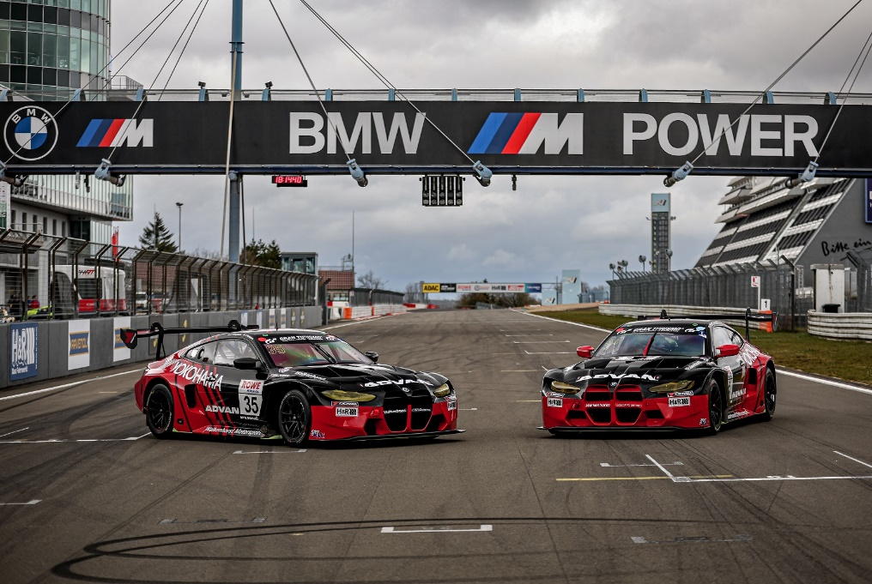
Two BMW M4 GT3 cars featuring the ADVAN logo and colors will compete in this year’s Nürburgring 24-Hour Race

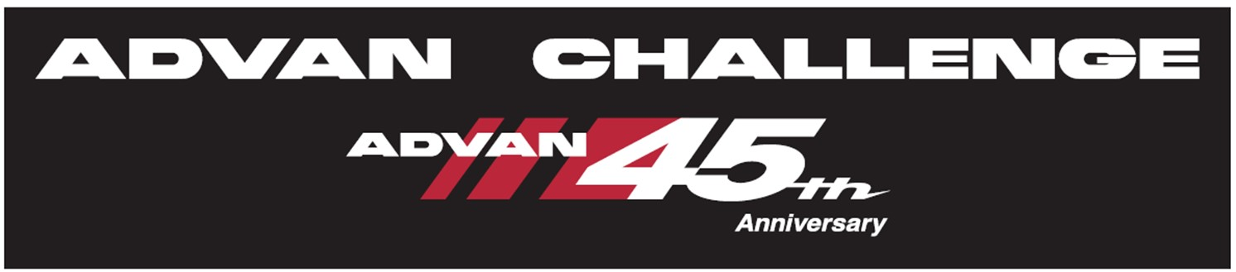
ADVAN CHALLENGE logo

