28th March 2022

YOKOHAMA to supply tyres to Team Mitsubishi Ralliart participating in the Asia Cross Country Rally

YOKOHAMA announced today that it will supply its GEOLANDAR M/T G003 mud-terrain tyres for SUVs and pick-up trucks to support Team Mitsubishi Ralliart as it seeks to win this year’s Asia Cross Country Rally (hereafter AXCR), Asia’s largest cross-country rally, which will be held this year during 6th – 12th August.

AXCR is an FIA certified event that was first held in 1996. This year’s event will be the first running of the AXCR, a cross-country rally similar to the Dakar Rally, in three years. In recent years, the AXCR has been run over a different course each year, with the starting line in Thailand and then passing through many Southeast Asian countries as it winds through a diverse range of terrains, from mountains and jungles to beaches and plantations, and even race circuits.

Team Mitsubishi Ralliart is a private team operated by TANT SPORTS (Thailand) with technical support from Mitsubishi Motors Corporation. This year the team will be competing in a Triton, Mitsubishi Motors' global strategic model one-ton pickup truck. YOKOHAMA’s GEOLANDAR M/T G003 ty tyres deliver superior performance on the full range of off-road surfaces over an exceptionally long lifespan. In addition, the tyre features a sturdy and aggressive design that enhances the off-road driving sensation. YOKOHAMA’s GEOLANDAR brand tyres, including the M/T G003, are widely used in motorsports and have performed brilliantly in many of the most demanding off-road races in Asia, North America, and other regions.

Under YOKOHAMA’s three-year (2021–2023) medium-term management plan, Yokohama Transformation 2023 (YX2023), the consumer tyre business aims to maximize the sales ratios of high-value-added YOKOHAMA tyres, namely the global flagship ADVAN brand, the GEOLANDAR brand of tyres for SUVs and pick-up trucks, and various winter tyres.YX2023 also positions participation in motorsports activities as crucial to the company’s effort to develop new tyre technologies that will further strengthen the ADVAN and GEOLANDAR brands. YOKOHAMA therefore is again participating in a wide variety of motorsports events in Japan and around the globe, from top-category to grassroots events.

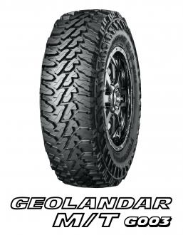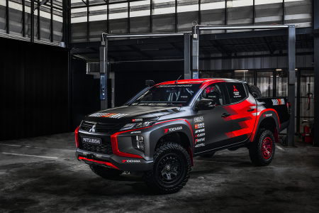
Mitsubishi Triton Rally Car *The above photo is used with the permission of Mitsubishi Motors Corporation. Reprint or other usage of this image without prior permission from Mitsubishi Motors Corporation is strictly prohibited.

