4th September 2023

YOKOHAMA to support Kalle Rovanperä in Round 6 of FORMULA DRIFT JAPAN race following first-place finish in Round 2

YOKOHAMA announced today that it will be supplying its global flagship ADVAN brand tyres and wheels to the 2022 FIA World Rally Championship (hereafter, WRC) winner Kalle Rovanperä in Round 6 of FORMULA DRIFT® JAPAN (hereafter, FDJ), to be held on 7th and 8th October on the Okayama International Circuit in Okayama Prefecture. Following Round 2 in April this year, in which Rovanperä finished first, this is the second time that YOKOHAMA will be providing support. Rovanperä will participate again in the Red Bull GR COROLLA from KR69 CUSCO Racing. As part of this year’s ADVAN CHALLENGE, which seeks to maximize sales of ADVAN tyres during the brand’s 45th year, YOKOHAMA is strengthening recognition of the ADVAN brand as a tyre with superior performance through motorsports.

Kalle Rovanperä is a rally driver from Finland. He began full participation in WRC in 2020. After finishing the 2021 season with two victories and an overall fourth place driver’s ranking, in 2022, he became the youngest WRC champion at the age of 22. In 2023, he has continued his steady rise, taking the sole lead as of the end of Round 9. Having mastered drifting techniques by the age of eight, Rovanperä has deep knowledge of drift competition and has participated in the Drift Masters European Championship series. Round 2 was his first FDJ race. He passed the qualifying race in first place and won the final race in a commanding display of skill.

As with Round 2, YOKOHAMA will be supplying Rovanperä with the ADVAN NEOVA AD09, YOKOHAMA’s strongest street sports tyres, which have a well-balanced combination of enhanced levels of dry grip, controllability, and wear resistance. The tyres will come fitted with ADVAN Racing GT BEYOND aluminium sports wheels. YOKOHAMA expects its support for Kalle Rovanperä, who is attracting global attention as a phenomenal young driver competing in drifting competitions that require the most advanced techniques, to help raise recognition of the ADVAN brand as a tyre with superior performance.

FDJ is an international version of the FORMULA DRIFT® series held in the United States. FDJ, held since 2014, essentially is a reverse import from the US FORMULA DRIFT®, which has elevated the popularity of drift driving, a motorsport that originated in Japan.

Under YOKOHAMA’s three-year (2021–2023) medium-term management plan, Yokohama Transformation 2023 (YX2023), the consumer tyre business aims to maximize the sales ratios of high-value-added YOKOHAMA tyres, namely the global flagship ADVAN brand, the GEOLANDAR brand of tyres for SUVs and pick-up trucks, and various winter tyres.YX2023 also positions participation in motorsports activities as crucial to the company’s effort to develop new tyre technologies that will further strengthen the ADVAN and GEOLANDAR brands. YOKOHAMA therefore is again participating in a wide variety of motorsports events in Japan and around the globe, from top-category to grassroots events.
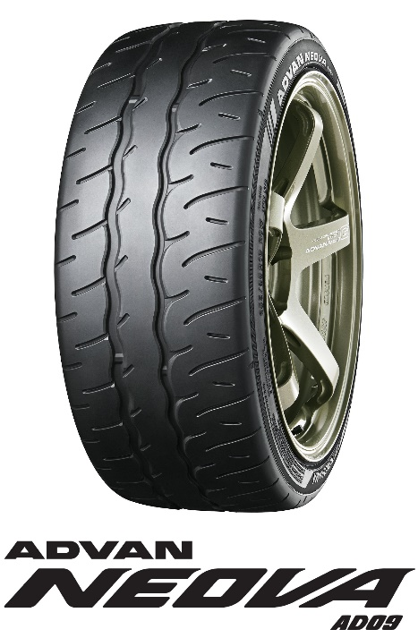

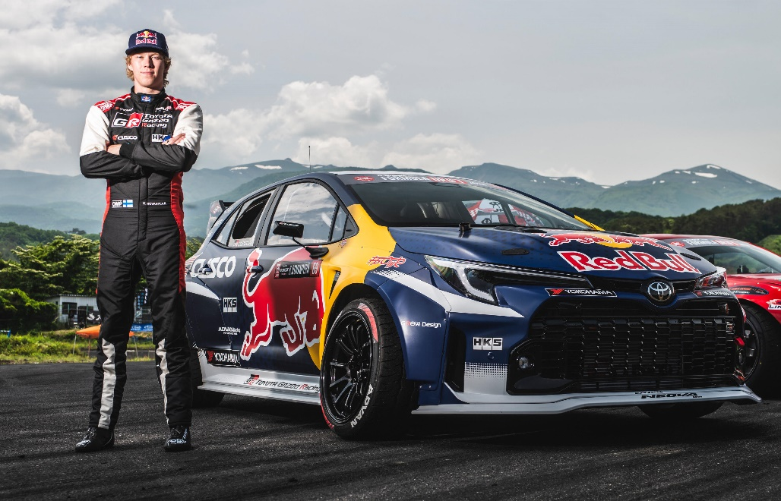
Rovanperä and his vehicle

