9th December 2021

YOKOHAMA launches two new fuel-efficient tyres - BluEarth-RV RV03 and BluEarth-RV RV03CK for minivans and lightweight box wagons

YOKOHAMA announced today that it will introduce two new tyres for its fuel-efficient BluEarth brand line-up in February 2022. Sales of the BluEarth-RV RV03 for minivans will be launched first in Japan and gradually expanded to other Asian countries. The BluEarth-RV RV03CK for compact minivans and lightweight box wagons will be launched in Japan only. The two tyres will be available in 40 sizes, ranging from 245/40R20 99W XL to 145/80R13 75S.

The BluEarth-RV RV03 shall be YOKOHAMA’s first all-new fuel-efficient tyre for minivans in seven years. In addition to securing the same high evaluation as its predecessor BluEarth RV-02 and receiving the Japan tyre-labelling system’s highest “a” grade for wet grip performance and “A” grade for rolling resistance*1, the BluEarth-RV RV03 sustains its predecessor’s excellent uneven wear resistance and stability. In addition, the tyre’s enhanced wear resistance and quietness provide new value-added befitting its basic concept as a "longer-lasting and more comfortable tyre for minivans." The tread pattern, based on the predecessor’s asymmetric pattern, features a finely optimized tread profile and ratio of groove and sipe areas. In addition, YOKOHAMA’s cutting-edge rubber-mixing technology, “A.R.T. Mixing,” was used to develop an exclusive-use compound that enhances the tyre’s road-surface followability.
These enhancements have raised BluEarth-RV RV03’s wear resistance by 20%*2 and reduced road noise to provide a quieter ride in the minivan’s second and third row seats as well as in the driver and front-row passenger seats.

The BluEarth-RV RV03CK will be YOKOHAMA’s first all-new fuel-efficient tyre for compact minivans and lightweight box wagons since it launched the predecessor BluEarth RV-02CK five years earlier in 2017. The application of the same technologies used in the new BluEarth-RV RV03 has raised the BluEarth-RV RV03CK’s wet-grip performance from its predecessor’s “b” grade to “a” on all tyre sizes. In addition, it has received an “A” grade for rolling resistance.
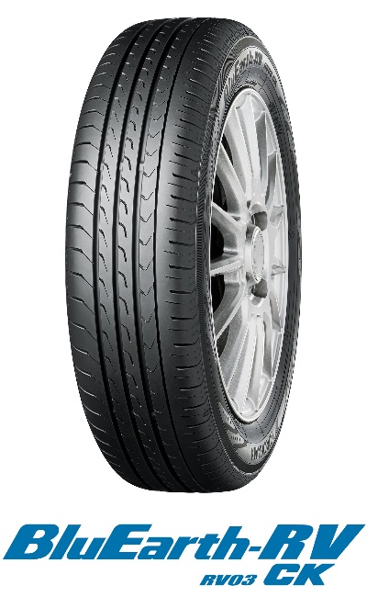
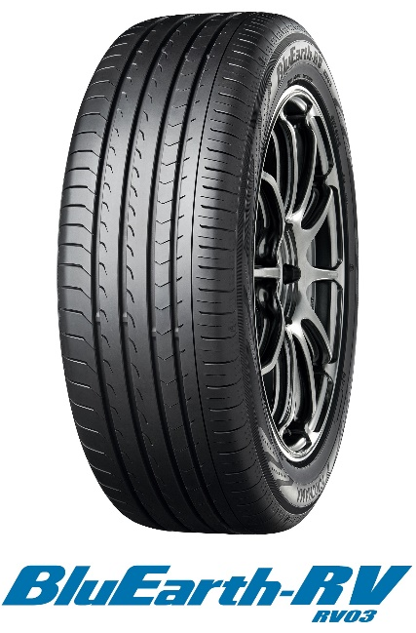

BluEarth is a YOKOHAMA global tyre brand based on the concept of being “environmentally, human, and socially friendly.” The BluEarth brand line-up of fuel-efficient passenger car tyres includes nine tyres. In addition to minivan tyres, the line-up includes a crossover SUV tyre, a grand-touring tyre, standard tyres, an all-season tyre.

Under YOKOHAMA’s three-year (2021–2023) medium-term management plan, Yokohama Transformation 2023 (YX2023), the consumer tyre business aims to maximize the sales ratios of high-value-added YOKOHAMA tyres. Accordingly, YOKOHAMA plans to strengthen sales of its summer tyres in 2022. In addition to announcing the launch of the BluEarth-RV RV03 and the BluEarth-RV RV03CK, the Company simultaneously has announced two additions to its ADVAN global flagship
tyre brand - the ADVAN Sport V107 and the ADVAN NEOVA AD09.

*1 Seven of BluEarth-RV RV03’s 29 sizes have attained “AA” rolling-resistance ratings.
*2 Refer to the performance data for detailed test contents. Performance data has been submitted to Japan’s Tire Fair Trade Council.

Available Sizes
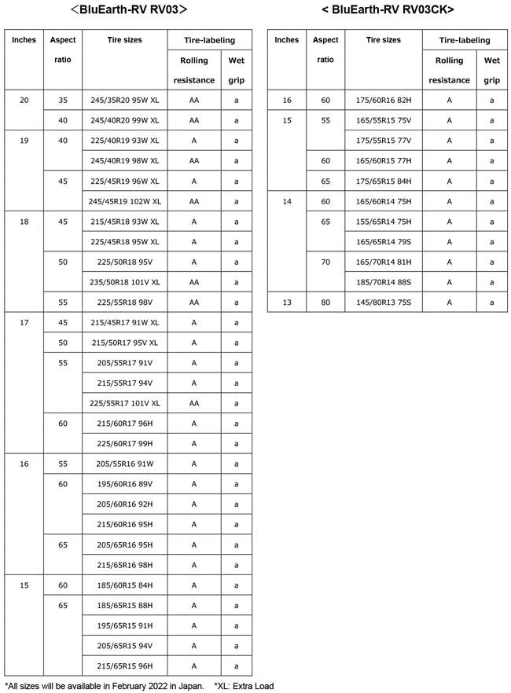

Improved quietness and considerations especially for MPVs

Enjoy even more quietness inside the vehicle. Quietness has been improved, while also cutting down on wobbling and uneven wear.
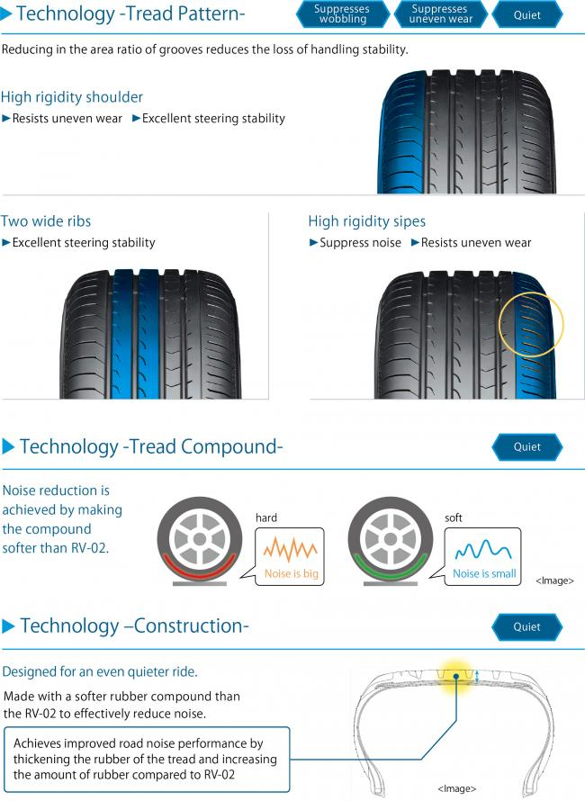

Longer wear life with the same high performance on wet surfaces

Enjoy long-lasting safety and peace of mind. High performance in rain, with an even longer wear life.

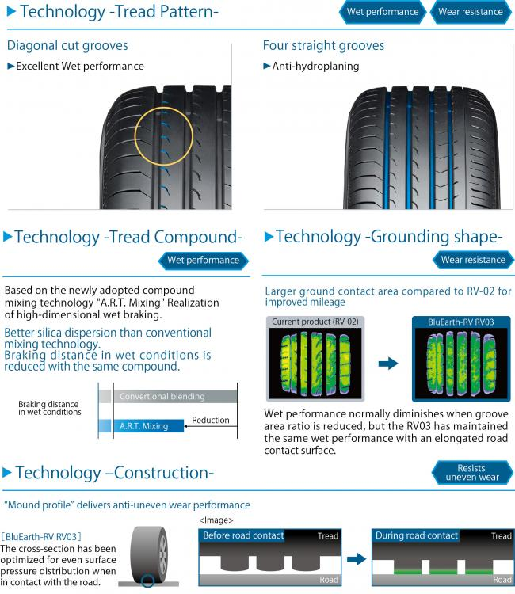

Performance data
