19th January 2024

Yokohama HPT announces new Managing Director

YOKOHAMA HPT is pleased to announce the appointment of Marisa Hever-Smith as the new Managing Director of YOKOHAMA HPT Ltd as of 1st April 2024.

Marisa Hever-Smith, currently CFO, will assume the role of Managing Director for the UK business from 1st April 2024. Marisa has been with YOKOHAMA since September 2022 and prior to that was Finance Director at Prometeon Tyre Group.

These changes are part of a transformation project to ensure YOKOHAMA continues its growth within the UK, in both the PCR and TBR markets, for the coming years.

Peter Fairlie will remain within the YOKOHAMA family as a consultant to support the senior management team as they continue to strengthen YOKOHAMA's position in the UK market.

Marisa Hever-Smith says "I am delighted to be taking on this role and I look forward to building on the strong foundations that have been put in place. We have built an excellent team in the UK, and I know we have the ability, the products and the mind set to grow further within the UK market.”

Notes
Yokohama HPT Ltd is the UK distributor of passenger car, 4x4 and motorsport tyres from Japanese manufacturer Yokohama, the oldest Japanese and world’s eighth largest tyre manufacturer who celebrated its centenary in 2017.

Many vehicle manufacturers around the world select Yokohama tyres as original equipment on their cars including all major Japanese and a growing number of premium European makers including Audi, BMW, Mercedes-Benz and Porsche.

The company’s products have developed an enviable reputation with performance enthusiasts which reflect its motorsport pedigree.

Useful Links
Yokohama – www.yokohama.co.uk

Pictures
For high resolution copies of these images, please contact danny@redmarlin.co.uk or call 01926 832 395

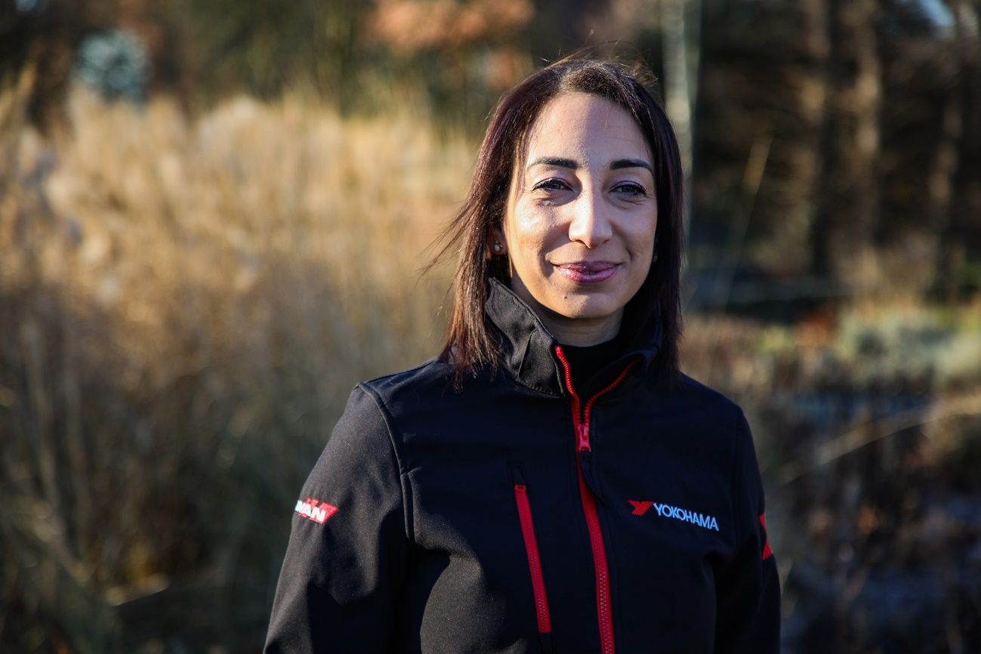
Marisa Hever-Smith becomes the new Managing Director of YOKOHAMA HPT Ltd as of 1st April 2024

