PRESS RELEASE
Yokohama UK strengthens its senior management team with new appointment
- Peter Fairlie is joining the company in the role of CEO

Peter Fairlie has been named as the new CEO of Yokohama HPT Ltd and will join the company on July 13th.
Peter brings with him a wealth of tyre industry experience having operated at board level, most recently as managing director of Prometeon (UK) and prior to this as retail and fleet director at ATS Euromaster.
Nick Greenfield will remain with Yokohama to support Peter as the company continues to grow and strengthen its UK business.
Peter commented “Yokohama has already gained significant brand awareness and increased market share in the premium segment. I look forward to joining Yokohama HPT and leading the UK team as we move to the next phase of the company’s development”.
Peter and the rest of the Yokohama management team will work closely to further develop product and customer channels.
This strengthening and restructure will ensure that Yokohama is best placed to achieve its strategy of continuing to grow sales and market share, particularly of Yokohama ADVAN and Geolandar products which already have a significant presence within the high inch premium segments.

Notes
Yokohama HPT Ltd is the UK distributor of passenger car, 4x4 and motorsport tyres from Japanese manufacturer Yokohama, the oldest Japanese and world’s eighth-largest tyre manufacturer celebrated its centenary in 2017.
Many vehicle manufacturers around the world select Yokohama tyres as original equipment on their cars including all major Japanese and a growing number of premium European makers including Audi, BMW, Mercedes-Benz and Porsche.
The company’s products have developed an enviable reputation with performance enthusiasts which reflects its motorsport pedigree. Indeed, Yokohama’s tyres are used by competitors in 28 motorsport series in the UK in 2022.
Alongside its high-profile motorsport activities, Yokohama is the official tyre partner of Chelsea FC and the official tyre partner of The Classic, held at Silverstone circuit, giving the brand further extensive global exposure.
Useful Links
Yokohama – www.yokohama.co.uk
Pictures
For a high resolution copy of this image, please contact the press contacts listed below or call 01926 832395
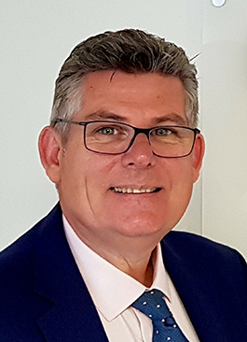 | Peter Fairlie has been named as the new CEO of Yokohama HPT Ltd, effective from 13 July.

PR Contacts

Danny Rughoobeer at Red Marlin
danny@redmarlin.co.uk
T 01926 832395
M 07739 878365
Ref:

